# ***Planting Agent*** Technical Report

Course id :AI314

# Autonomous Multiagent Systems

# Instructor : Dr. Mohamed A. Wahby

|  |  |
| --- | --- |
| Name | ID |
| Ahmed kadry | 20180018 |
| Loai gamal | 20180206 |
| Mohamed sayed | 20180224 |
| Marina moheb | 20180208 |

22 MAY - Spring 2021

Technical Report#2

# Formulate the problem precisely:

* What is our problem?
* In the current generation most of the countries do not have sufficient skilled man power especially in agricultural sector and it affects the growth of developing countries. The main requirement of Automation is to reduce man power in our country. Automation saves a lot of tedious manual work and speeds up the production processes. So it is time to automate the sector to overcome this problem. So In this model the problem is in sowing the seeds.
* What is our problem type of formulation ?
* An incremental formulation : that involves operators that augment the state description, starting with an empty state.

# Formulation

* States:
* Position of the robot.
* Bucket of the seeds is empty or not.
* The soil seeded or not.
* Initial state:
* Start of line.
* Bucket of seeds is not empty.
* The soil not seeded.
* Actions:
* Move forward on the line.
* Fill the bucket of the seeds if it empty.
* Dig the soil to make it okay for seeding.
* Seeded the soil by the seeds.
* Transition model:
* When it complete seeding in the soil on the hole line.
* Goal test:
* End of the line.
* Bucket of seeds is not empty.
* The soil is seeded.

# Diagram of the complete state space:

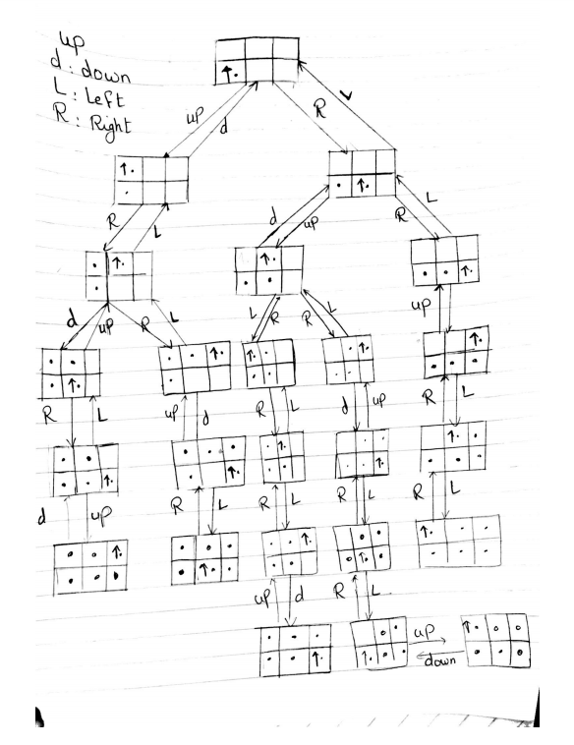

# The problem using two different search algorithms: